**ASSIGNMENT 2**

**PORTFOLIO**

**1.HOME PAGE**

When clicking on home it navigates to the section (home) in the website

**2.ABOUT PAGE**

It directly navigates to the about me page

**3.SKILLS PAGE**

Navigates to the skills page

**4.PROJECT PAGE**

When we click on the single project and clicks on ,more info button its shows a pop up

Here as an example I choose the first project.

**5.CONTACT PAGE**

HTML CODE:

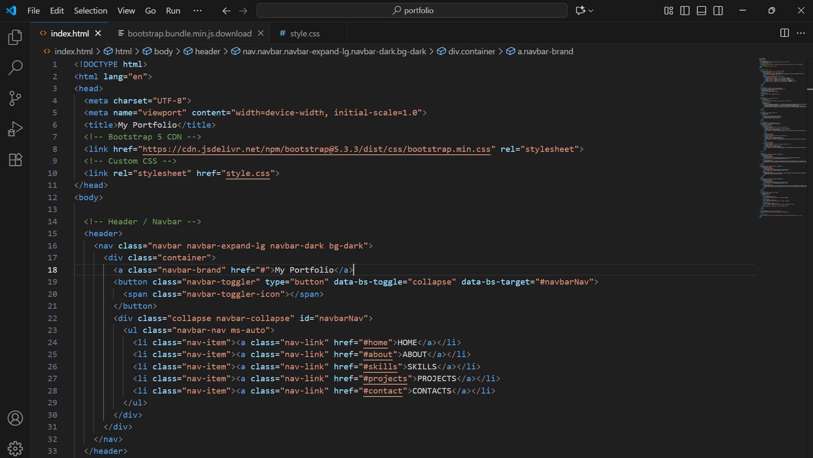

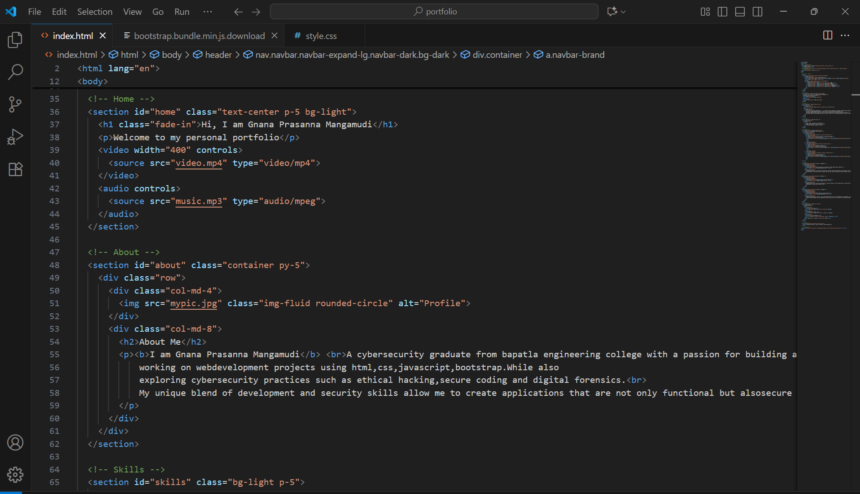

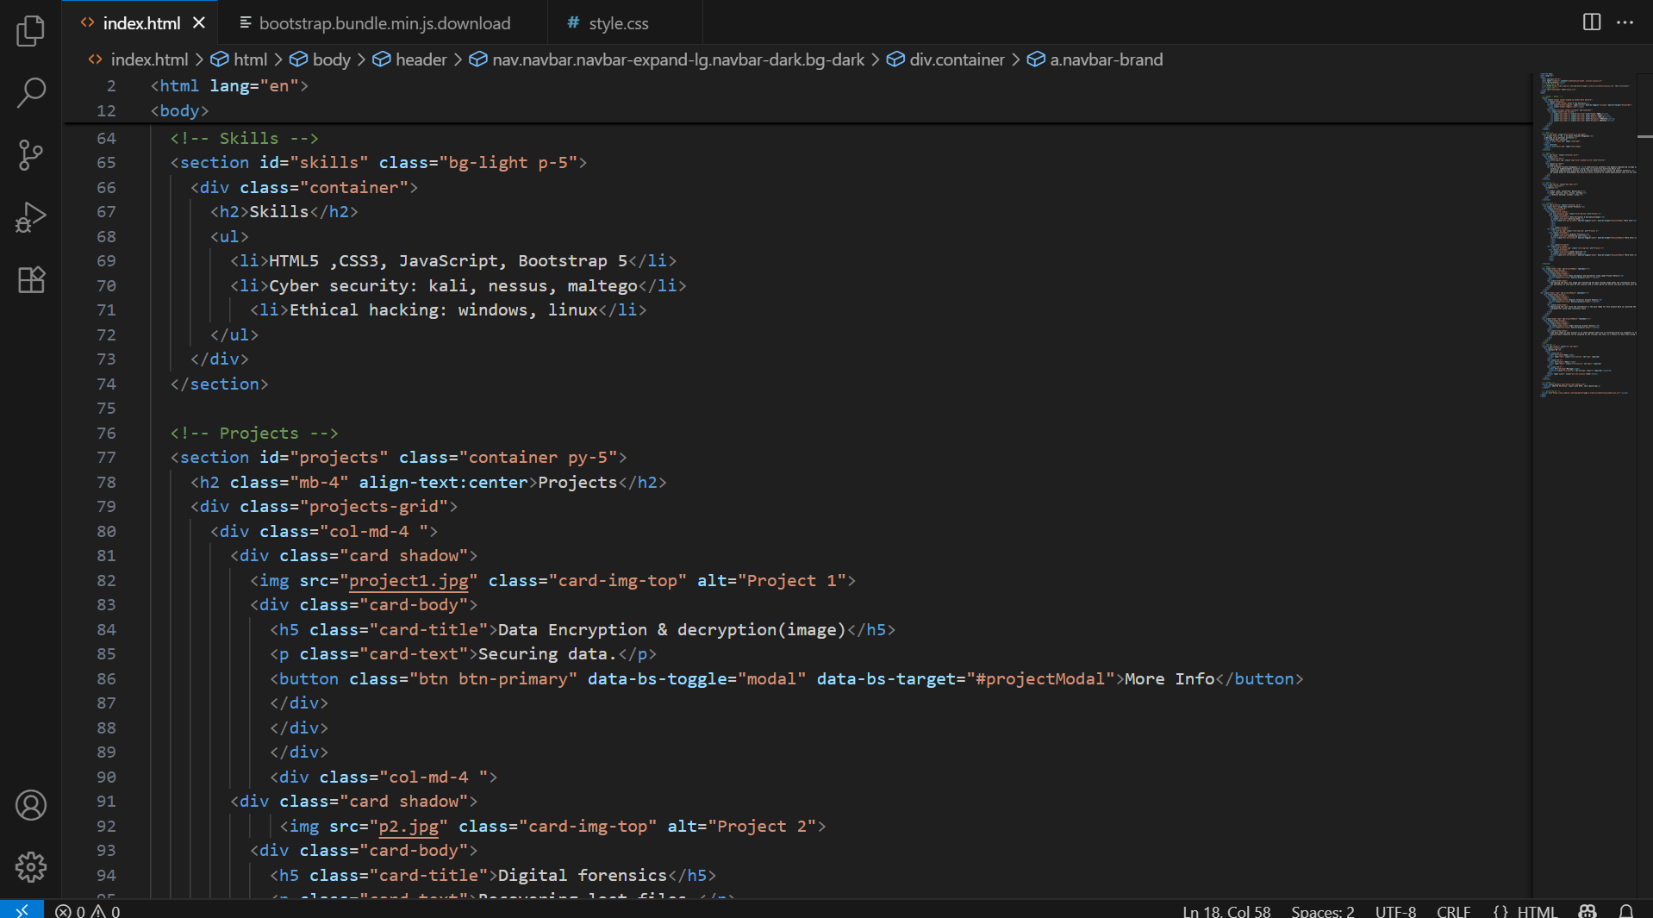

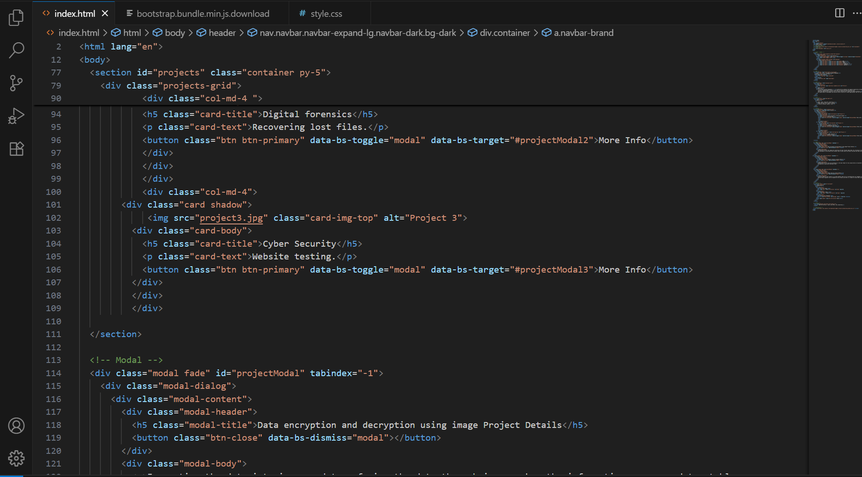

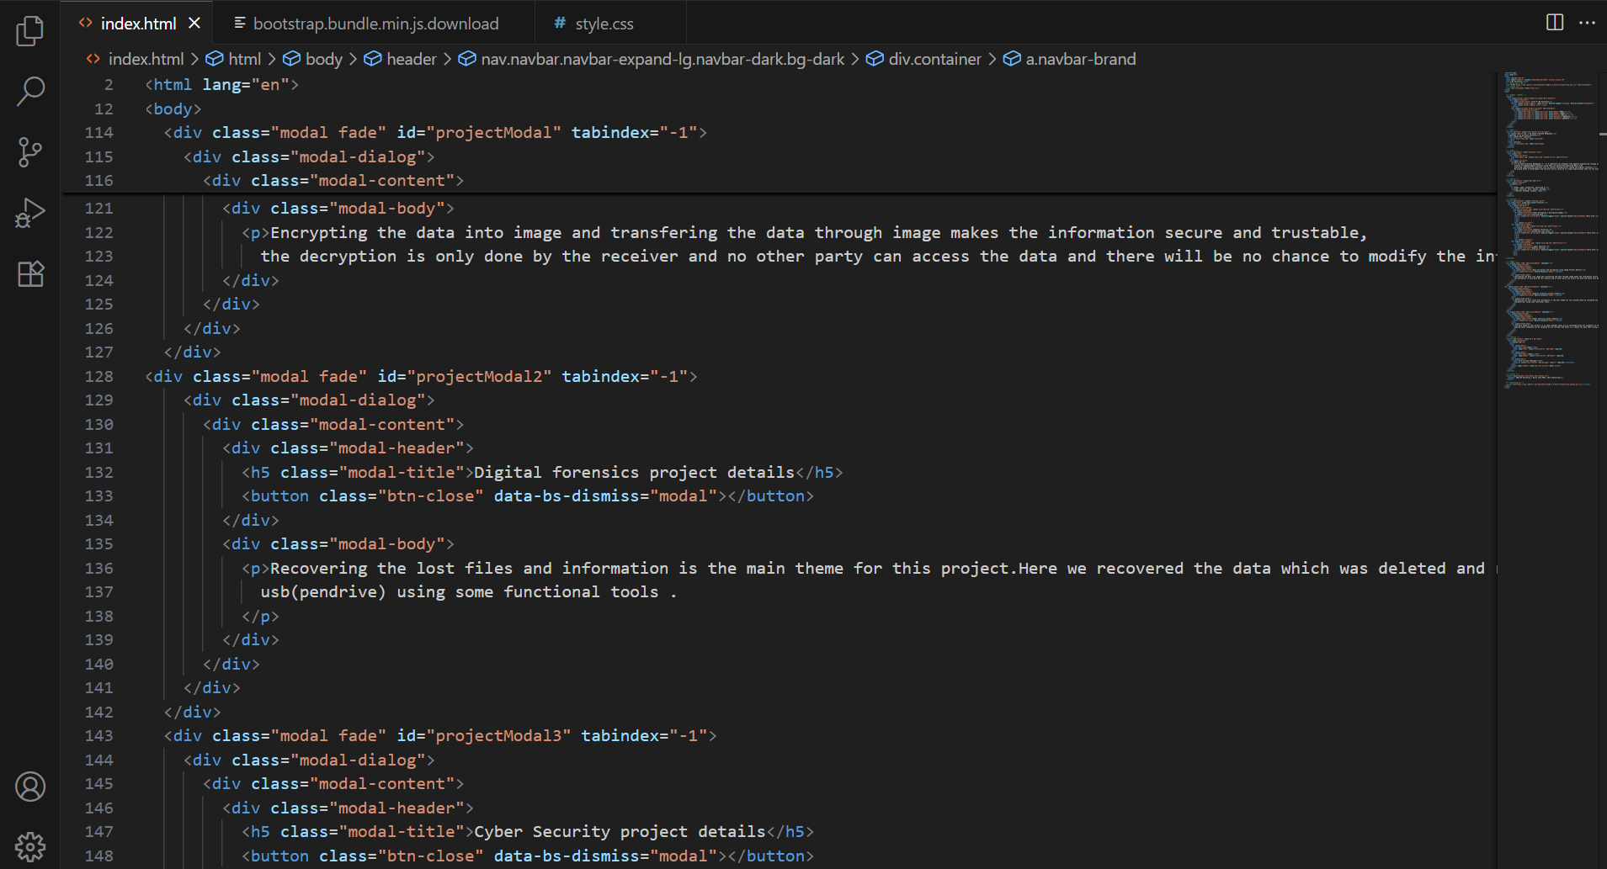

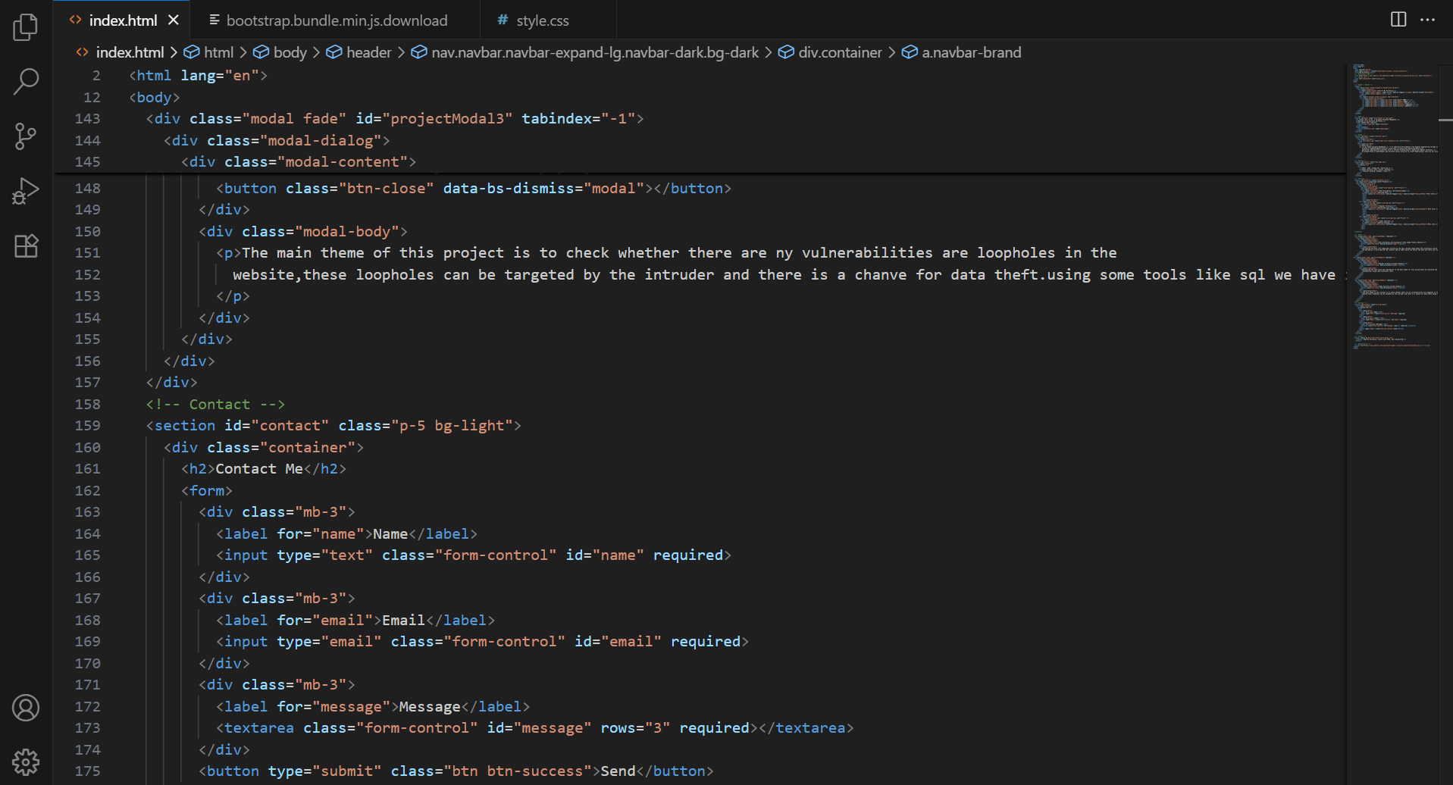

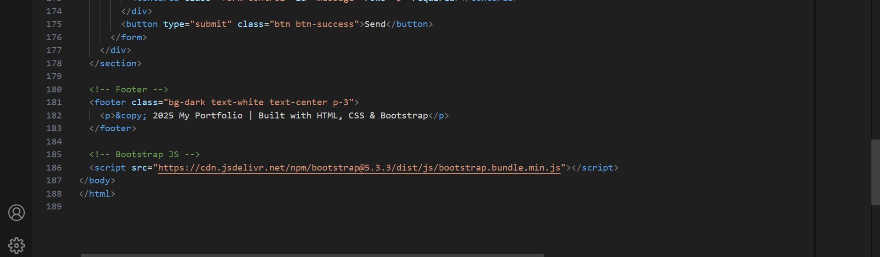

**CSS CODE**

